From: https://historyofyesterday.com/russia-the-us-and-uk-sealed-ukraines-fate-at-budapest-30-years-ago-15e1a6c3d6fe
Author: Prateek Dasgupta, MS
Mar 8, 2022
A 7 min read
Listen

Russia, the US, and UK Sealed Ukraine’s Fate at Budapest 30 Years Ago
Former foes sat down to take away the third-largest nuclear arsenal in the world.

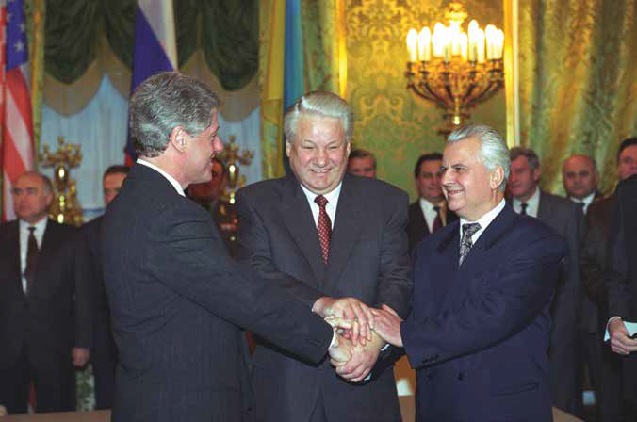
US President Clinton (left), Russian President Yeltsin (center) and Ukrainian President Karvchuk (right) after signing the Moscow trilateral agreement in 1994. Image source: Wikimedia Commons.
Ukraine’s future hangs in the balance. The Russian invasion of Ukraine should never have happened. Ukraine has become a victim of re-ignited Cold War politics because of incompetent leadership and bad decision-making.
With fingers pointing at NATO and Russia for the current debacle, we must take a step back and wonder if we could have prevented this horrific humanitarian calamity.
Ukraine has become a playground for superpower politics. Since Ukraine declared independence from the Soviet Union in 1991, major world powers have decided the country’s destiny.
Could we have avoided the present-day war?
We will never know for sure.
But, based on the history of nuclear powers not engaging in a full-fledged war, we may presume that things would have been different today if Ukraine had not given up its nuclear weapons.
Ukraine had the world’s third-largest nuclear arsenal. It surrendered all of its nuclear weapons as part of the Budapest Memorandum in 1994.
So, why did Ukraine hand over its nuclear weapons?
Short-sighted decision-making and willingness to trust superpowers have resulted in the current state of affairs.
Let us turn the clock back to the early 90s and take a trip to Eastern Europe to understand what happened between Ukraine, the US, the UK, and Russia.

Ukraine’s nuclear history after the collapse of the Soviet Union
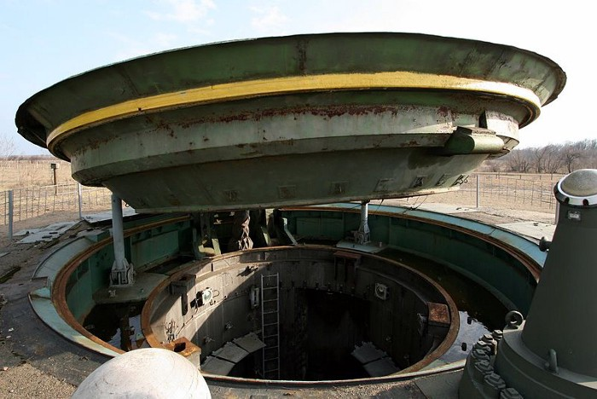
A missile silo in Central Ukraine for deployment of SS-24 ICBM. Image source: Wikimedia Commons.
Ukraine, the Soviet Union’s second-largest country, voted for independence on December 1, 1991. 90% of Ukrainians voted in favor of total independence.
Soviet Union was a nuclear power. One-third of the Soviet Union’s nuclear weapons were made and stored in Ukraine.
Ukraine’s nuclear arsenal included 130 UR-100 N ICBMs (inter-continental ballistic missile) with six nuclear warheads each and 46 RT-23 Molodet ICMBs with ten warheads apiece. Also, there were 33 heavy bombers with a total of 1700 warheads on Ukraine’s soil.
After the United States and Russia, the country had the world’s third-largest nuclear arsenal. Besides Ukraine, Belarus and Kazakhstan also inherited nuclear weapons from the Soviet Union.
Nuclear weapons serve as a deterrence for future invasions and full-fledged conflict. However, maintaining them is rather expensive.
In the early 1990s, poverty gripped Ukraine, Kazakhstan, and Belarus, and millions of people went hungry. Cash was in short supply.
As the cost of keeping the weapons increased, Kazakhstan and Belarus were willing to hand over their nuclear technology to Russia. Russia could assist the two countries since it had the technology and financial resources.
Ukraine was in a dilemma. It was on the fence about turning over its nuclear weapons and joining the Non-proliferation Treaty (NPT), an accord that advocates disarmament and the peaceful use of nuclear technology.
Ukrainians feared they would lose their deterrence against a future attack if they turned up their nuclear weapons to Russia. But only a few people in the world shared this belief.
One of them was John Mearsheimer, a distinguished political scientist and University of Chicago professor who predicted in 1993 that Ukraine would be susceptible to a Russian attack if it did not have nuclear weapons.
To further complicate matters, Russia was well-versed in all aspects of the nuclear technology of Ukraine, including the codes used to fire missiles. They were adamant about not sharing the relevant information with the Ukrainians.
Ukrainians could, of course, ask other nuclear states such as the United States, France, China, and the United Kingdom for help with the nuclear program. But the other superpowers were also unwilling to help Ukraine.
The United States went one step further, promising Ukraine economic help for handing over its nuclear weapons to Russia.
Ukraine was in a fix. It needed the money, but it also wanted a complete guarantee that Russia would not invade again.
What was the solution?

The Budapest Memorandum, 1994: The great betrayal
Ukraine had limited options. It could follow the path of India, Pakistan, and Israel, the nations who refused to sign the NPT. Or it could hand over its nuclear weapons and receive benefits from both the US and Russia.
Since the citizens of Ukraine suffered from immense hardships, their leadership decided to accept US aid and hand over the nuclear weapons to Russia.
Ukraine got a $300 million financial package from the United States, while Russia agreed to waive up to $2.5 billion in gas and oil debts while also promising future supply of nuclear fuel to Ukrainian power plants.
The superpowers gave Ukraine an offer it couldn’t refuse.
Ukrainian President Leonid Kravchuk was having second thoughts about signing the deal. The Clinton administration applied pressure on Ukraine, claiming a refusal to sign the deal as a threat to US-Ukraine ties.
At the Moscow trilateral agreement, January 1994, Boris Yeltsin, the Russian president, applied further pressure on Kravchuk. Yeltsin assured that Russia wouldn’t invade Ukraine, and the Russians were willing to sign an agreement promising the same.
Kravchuk finally agreed to sign the NPT. Ukraine, Kazakhstan and Belarus’ decision to sign the NPT in exchange for certain guarantees from the superpowers was signed at Budapest on 5th December, 1994.
This agreement is known as the Budapest Memorandum on Security Assurances.
Ukraine, Belarus, and Kazakhstan received the following assurances from the superpowers, Russia, the UK, and the USA:
- The territorial borders of Ukraine, Kazakhstan and Bealrus would be respected.
- They (the superpowers) would refrain from military intervention in the nations (Ukraine, Belarus, and Kazakhstan).
- They (the superpowers) would not influence the politics of Ukraine, Belarus, and Kazakhstan using economic pressure.
- Superpowers would not use nuclear arms against Ukraine, Belarus, and Kazakhstan.
- Superpowers would seek the immediate intervention of the UN Security Council if any of the nations signing the treaty became a victim of aggression.
- The superpowers would consult one another to uphold their commitments.
The list of promises allayed many of the fears Ukraine had. The other nuclear heavyweights, China and France, did not sign the memo. They instead handed separate papers expressing support for nuclear disarmament.
Today we know it was a short-sighted and wrong decision to trust the superpowers.
Why would you cede your sole line of defense to countries that refuse to dismantle their nuclear arsenals? This is equivalent to signing a contract of giving up your gun to a person holding a gun and assuring you he will never threaten you.
Either both lay down their arms or the whole exercise is pointless.
Both NATO and Russia interfered in Ukraine’s internal politics on countless occasions and today we are at a stage where the ordinary humans are paying the price for their leaders’ follies.
Putin accused the US and NATO of orchestrating the 2014 Euromaidan protests, which led to Russia’s takeover of Crimea. He pointed out that US and UK violated the Budapest Memorandum.
Today, the US is accusing Putin of violating the Budapest Memorandum. It is safe to say superpowers kept none of their promises and interfered in Ukraine’s domestic and foreign policies on multiple occasions.
The entire agreement was a sham.
Today Ukraine bleeds. The predictions of Prof. Mearsheimer have come true. Ukraine became a pawn in superpower politics and its citizens are suffering. The Russian invasion ruined their lives.
Ukraine’s decision to accept aid in the exchange for giving up its weapons may have helped in the short term, but it is regretting the decision today. Ukraine has no leverage, and the superpowers have not kept up their end of the bargain.
US and UK will not risk a direct confrontation with Russia, even if it means a loss of Ukraine’s sovereignty. Russia will continue to cite NATO’s threat, though a legitimate concern, to justify its invasion, violating every single agreement they made.
The net loser is Ukraine and its people. The deal they signed three decades ago sealed their fate.
Politicians declare war. The battlefield is their chessboard. They live in the comfort of their offices and palaces, ordinary soldiers and civilians die. One such soldier refused to be another number in the game played by politicians. If you are interested to know about him, read the following story.

